

INSERT QR CODE

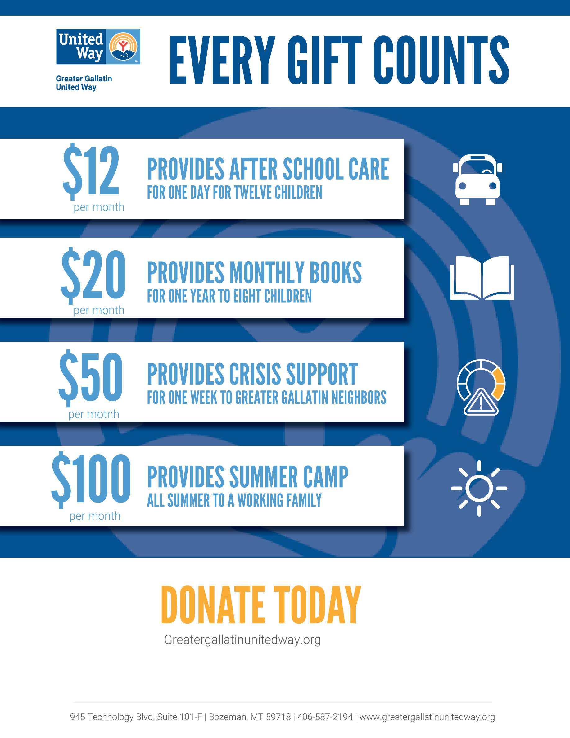

[COMPANY NAME] CAMPAIGN ENDS [DATE]

INSERT QR CODE

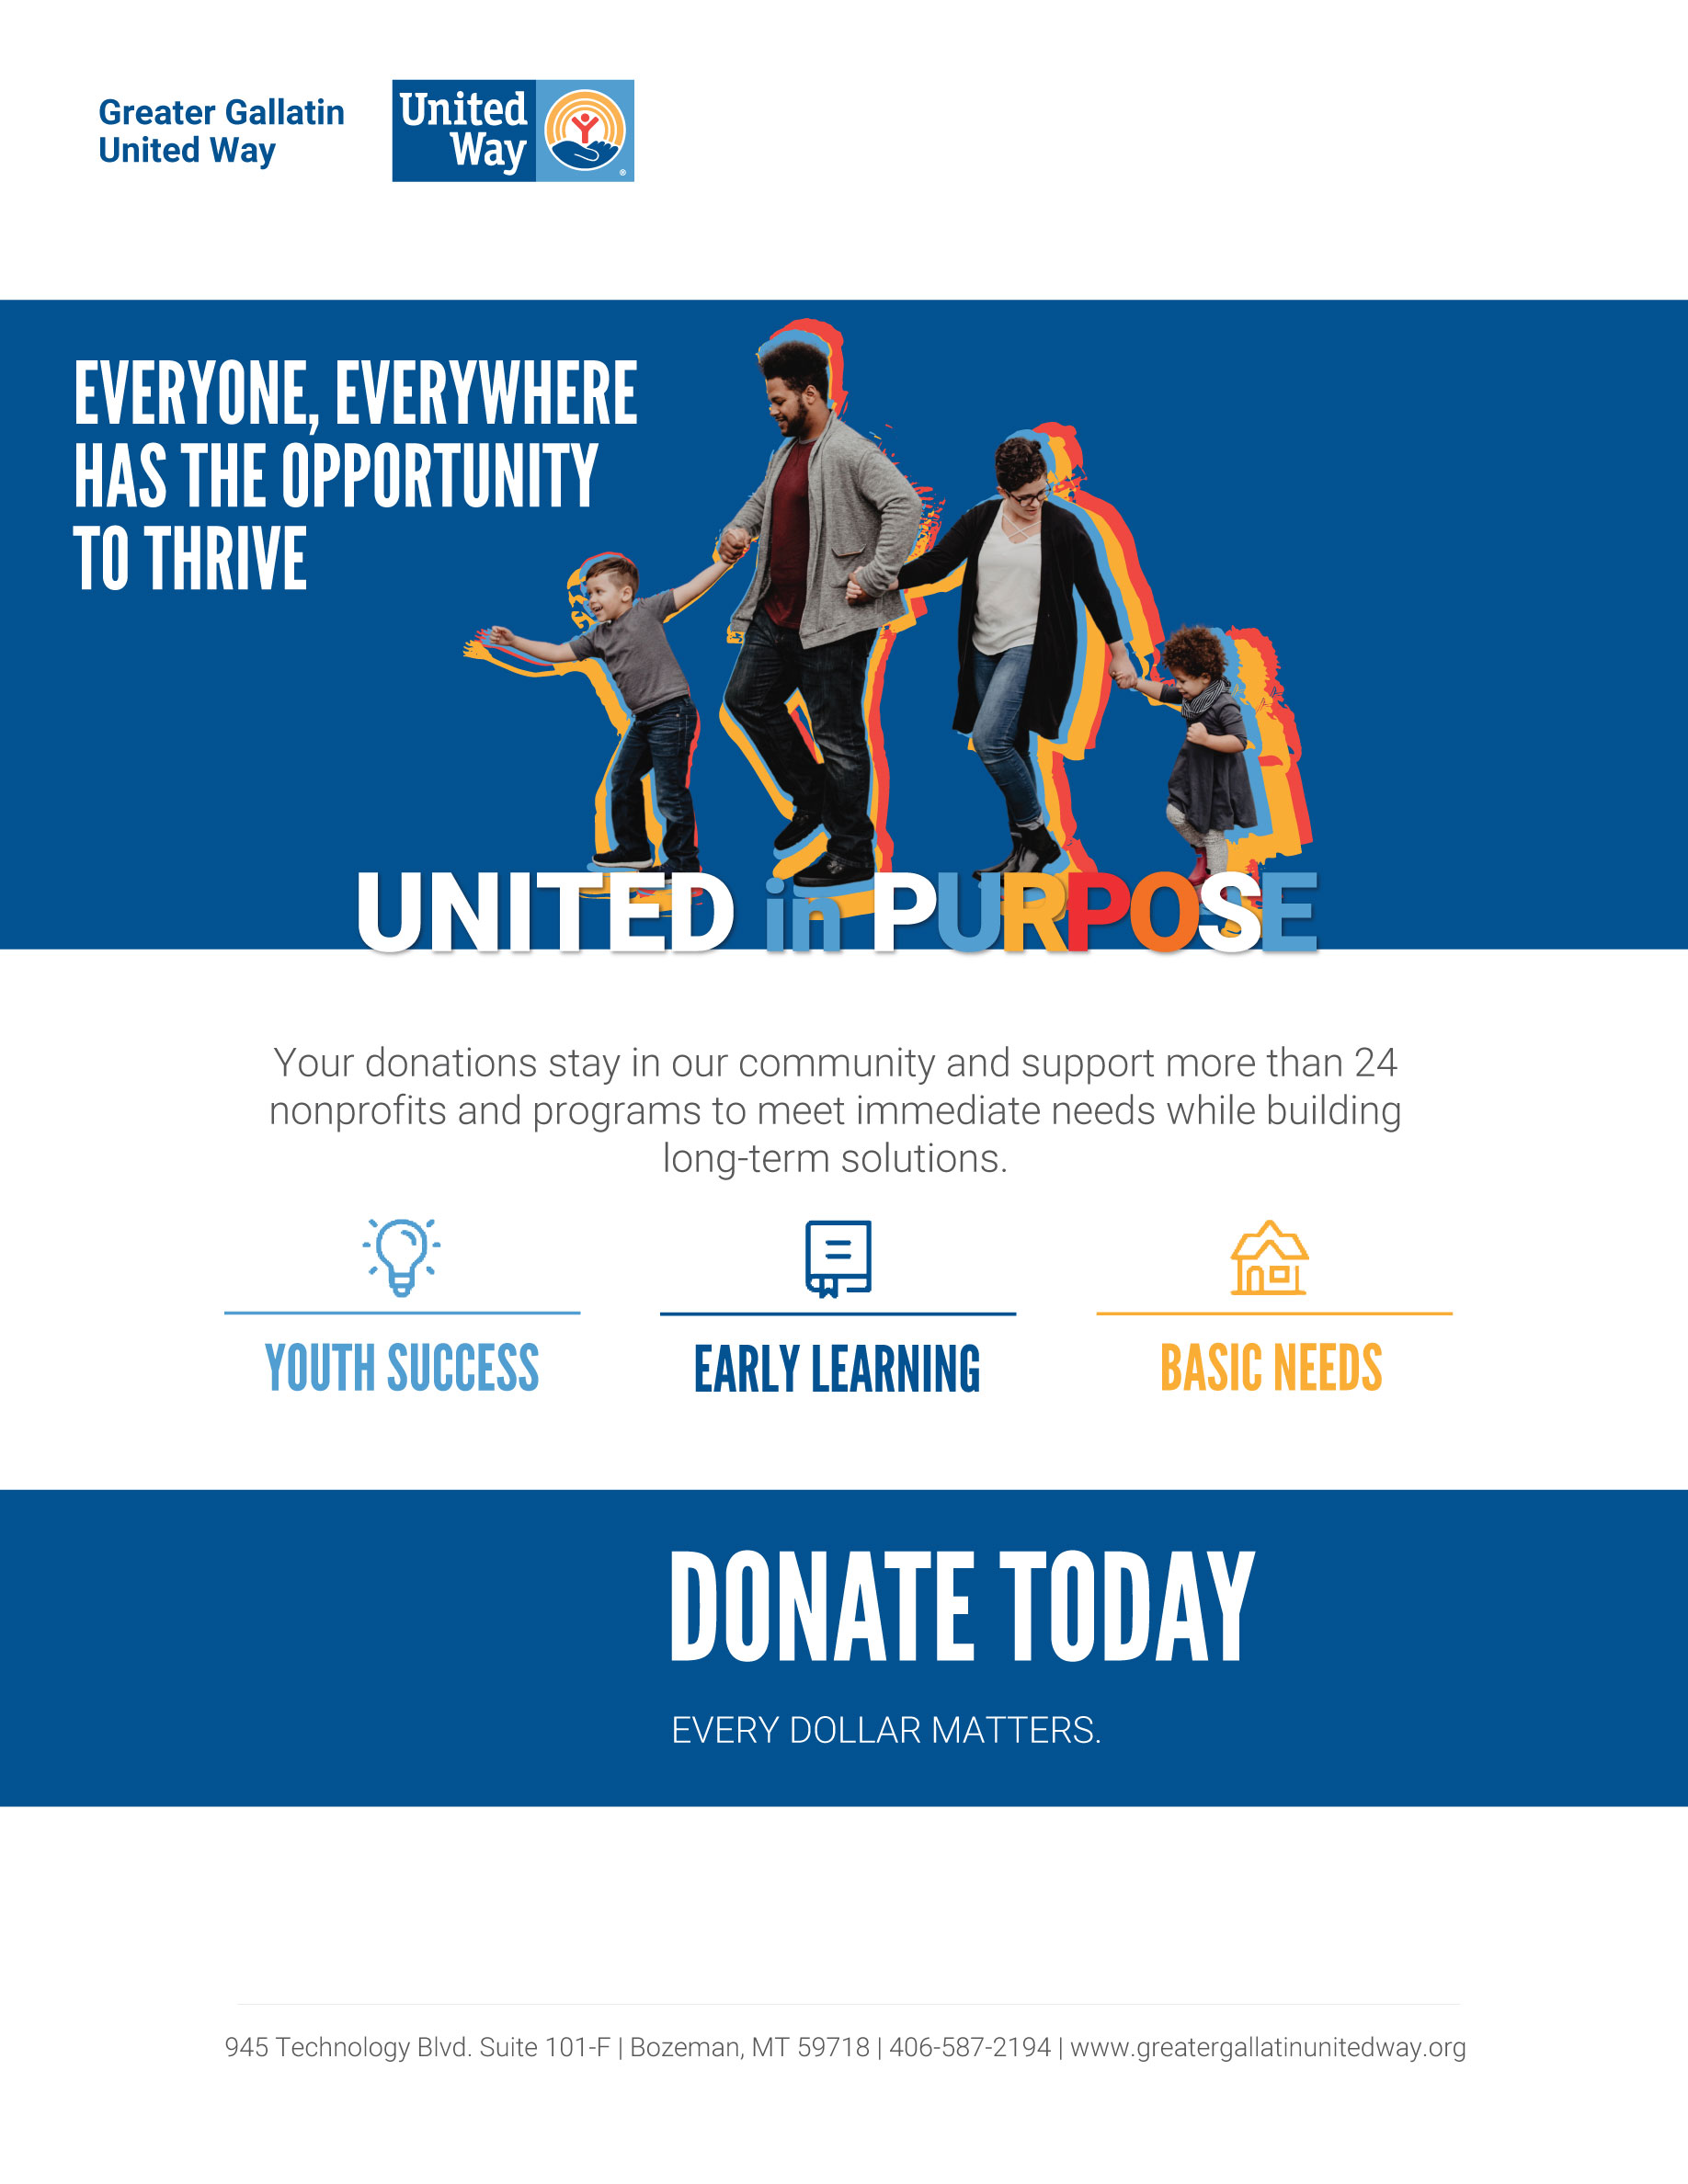

INSERT QR CODE

[COMPANY NAME] CAMPAIGN ENDS [DATE]

INSERT COMPANY LOGO